EXP. NO: 24
MATLAB SIMULATION OF PASSBAND TRANSMISSION WITH BER ANALYSIS UNDER MULTIPATH FADING CHANNELS
Objectives :
1. To simulate a digital passband communication system using MATLAB and study transmission through a multipath fading channel.
2. To generate a digitally modulated passband waveform, transmit it through a multipath fading channel, and recover the received data.
3. To evaluate system performance using Bit Error Rate (BER) under different signal-to-noise ratio (SNR) conditions.
4. To analyze the effect of multipath propagation, delay spread, fading, and additive noise on the received signal and BER performance.
5. To plot and interpret BER versus SNR characteristics and compare the simulated results with the expected communication-system behavior.
Procedure:
1. Open the MATLAB software and create a new script file.
2. Clear the command window, workspace, and close all previously opened figure windows.
3. Generate a random binary data sequence.
4. Perform BPSK modulation to obtain the passband transmitted signal.
5. Model the multipath fading channel.
6. Add noise to the faded signal.
7. Receive the transmitted signal through the multipath fading channel.
8. Demodulate the received signal and recover the transmitted binary data.
9. Calculate the Bit Error Rate (BER) by comparing the transmitted and detected binary sequences.
10. Display the transmitted signal, received signal, and BER comparison results.
11. Execute the MATLAB program.
12. Observe the effect of multipath fading on the received signal and analyze the BER performance.

PROGRAM :
clc;
clear;
close all;
% Parameters
N = 1000;
bits = randi([0 1],N,1);
% BPSK Modulation
tx = 2*bits - 1;
% Multipath Fading Channel
h = [1 0.5 0.3];
fade = filter(h,1,tx);
% Add AWGN
rx = awgn(fade,10,'measured');
% Detection
bits_rx = rx > 0;
% BER Calculation
[~, BER] = biterr(bits,bits_rx);
fprintf('BER = %f\n',BER);
% Plots
figure;
subplot(3,1,1)
plot(tx)
title('Transmitted BPSK Signal')
grid on
subplot(3,1,2)
plot(rx)
title('Received Signal (Multipath + AWGN)')
grid on
subplot(3,1,3)
stem(bits(1:50),'b')
hold on
stem(bits_rx(1:50),'r')
title(['BER = ' num2str(BER)])
legend('Original','Detected')
grid on
Output:
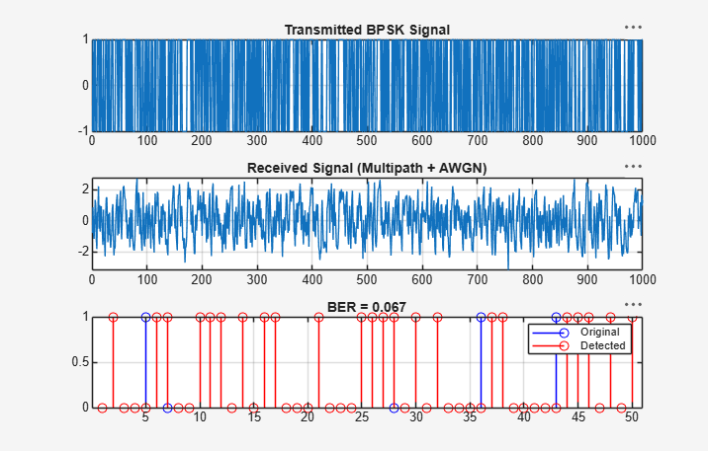
Result:
- The passband transmission system was successfully simulated in MATLAB, and the transmitted signal was recovered after propagation through the multipath fading channel.
- The Bit Error Rate (BER) analysis demonstrated the impact of multipath fading and channel noise on communication performance, indicating that increased fading and noise result in higher transmission errors.

